**Assignment-1**

| Assignment Date | 21 September 2022 |
| --- | --- |
| Student Name | Hariharan B |
| Student Roll Number | 921319104047 |
| Maximum Marks | 2 Marks |

| 1. Develop a Sample Homepage with HTML which should include banner, homepage Image & description about yourself and contact form: |
| --- |
|  |
|  |

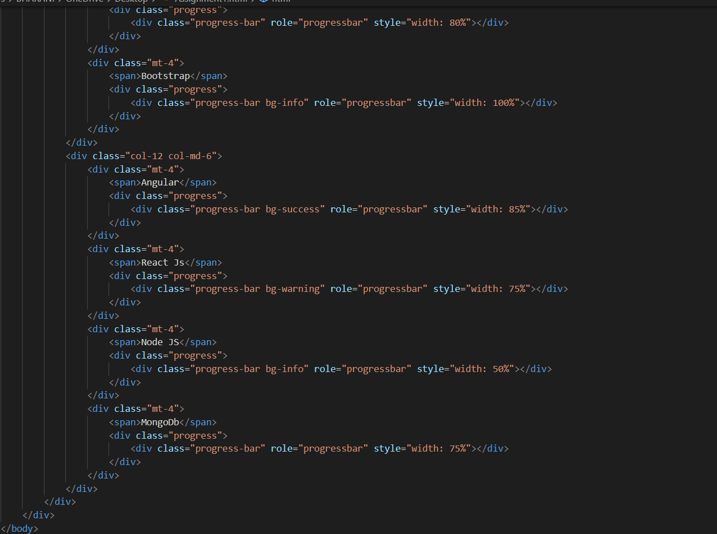

|  |  |
| --- | --- |

Output:

